Phuc Ton Nguyen

**Prediction of ticket pricing for Big Mountain Ski Resort**

Guided Capstone Project Report

**Introduction**

Introduction To price tickets for their resort, Big Mountain Resort uses a pricing model where they charge a premium above the average price of all the resorts in its market segment. The current price of Big Mountain Resort is $81. Their current pricing model doesn't give them insight on how to allocate funds for their investment strategy. By only utilizing average price it is unclear if the facilities they have or want to invest in support a higher ticket price. Additionally, it is unclear in which directions the business can costs such that the ticket price doesn't become overvalued. Understanding the impact of different facilities and features of the resort give Big Mountain Resort a keener sense on how to allocate their money to drive revenue and shed weight.

**Exploratory Data Analysis**

The current price of Big Mountain Resort is $81.

Currently it has the highest ticket price in its state Montana as compared to its competitors in the same state.

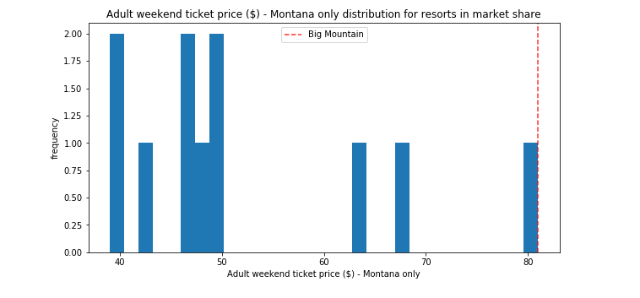

Below figure mentioned the Big mountain resort ticket price as compared to its competitors along different states of country USA.

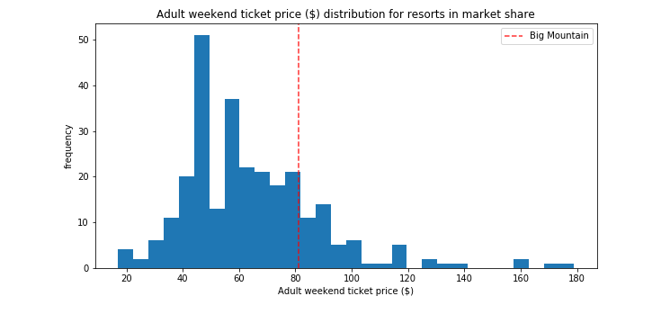

When comparing the ticket price of Big Mountain Resort with other competitors in the USA as per the overall facilities provided by the resorts, there is a prediction that our ticket prices are worth $94. This is an overall 16% increase over our current ticket price.

Principal Component Analysis The derived state data set had 7 features to choose from. A principal component analysis (PCA) was used to visualize the data in a lower dimension and see if it can give us insight on how to proceed with handling the state data. The PCA gave us justification for treating all states equally and to continue by building the model with all states being equal.

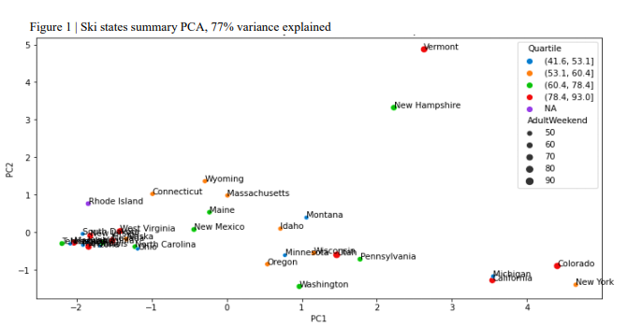

**Model**

After splitting the data in train and test sets, three models were selected to be fitted to the data: A Dummy Regression Model for the baseline test, a Linear Regression Model, and a Random Forest Model. In both the linear regression and random forest models a hyper-parameter search combined with a 5-fold cross-validation was used to find the parameters that produced the best metrics on the training set. After the best parameters were found another cross-validation was run using those specific parameters to assess the models by using the average of the 5 resulting mean absolute errors. The results of the training are as follows: ▪

* Dummy Regressor (Baseline): simply using the mean as the predictor, resulted in a mean absolute error of $19 when used on the test set. This means that this model can predict a ticket price within $19 of the real price.
* Linear Regression: after optimizing the model and running a cross-validation the average of all the mean absolute errors was $10.50 with a standard deviation of $1.62. The performance of this model is significantly better than the Dummy Regressor. When used to predict the price on the test set this model outputted a ticket price of $11.80.
* Random Forest: completed the same steps as in the linear regression model with an average mean absolute error of $9.64 and a standard deviation of $1.35. With a smaller average mean absolute error and a tighter standard deviation the random forest model performed the best and was chosen as our model going forward. When used to predict the price on the test set this model outputted a ticket price of $9.53.

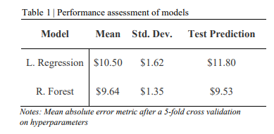

**Conclusion**

When fit on all the data and used to predict the price of Big Mountain Resort the model predicted a ticket price of $95.87 as compared to the current price of $81. Even with the expected mean absolute error of $10.39, this suggests there is room for a price increase. Based on the features that are dominant in both models, Big Mountain Resort is in the upper echelon when it comes to most of those features and explains why the model outputted such a high-ticket price. Of the four courses of action the business is willing to take the second scenario is the best course of action: Increase the vertical drop by adding a run to a point 150ft. lower, requiring an installation of a new chair lift to bring skiers back up. This change in the resort would support an increase in ticket price by $1.99 and increase revenue by approximately $3.4M for the season. Assuming the new chairlift would have the same operating costs as the old one, $1.54M should be deducted from the $3.4M generated. Other suggestions that should be taken into consideration.

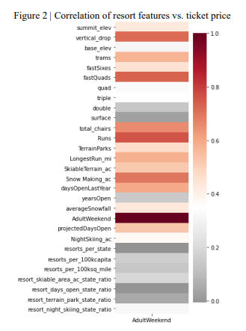

* Closing a single run does not affect the ticket price. However, closing 2 or more runs can cost the company anywhere from $700k to $2M+ in revenue.
* Adding a chair lift in isolation loses the business money. A new lift only supports a revenue increase of $507k ($0.29 per ticket) but would cost $1.54M in operating costs.
* Close the least popular run, which our model suggest conserves revenue. Then chose another run from the least popular runs list that could easily be extended to increase the vertical drop metric by 150ft and install the required chairlift. Ideally, the most popular run from the least popular list would be chosen to potentially save marketing costs needed to drive interest into the new run.